PREDICTING CAMPUS EVENT ATTENDANCE USING MACHINE LEARNING

Abstract
Planning student events on a college campus can be difficult because it is really difficult to determine how many people will be in attendance. As a student leader, this is a problem I experience every week. This project explores whether machine learning can help predict event attendance using information like event type, promotion method, day and time, weather, and other details.
I created a dataset of 500 realistic campus events and trained several models, including Linear Regression, Decision Trees, Random Forests, and a Neural Network. I measured the accuracy of each model using MAE, RMSE, and R². The Random Forest model performed the best with an R² of 0.659, while the neural network performed poorly.
The results show that attendance is influenced by clear factors, such as free food, promotion style, and whether the event happens on a weekend. Overall, this project shows that machine learning can be a useful tool for planning campus events more effectively.

1. Introduction
Most college campuses host many different events every week, such as floor programs, club activities, workshops, and competitions. Event organizers often struggle to predict how many students will attend. This makes it hard to plan correctly. Bringing too much food or reserving too large a space can waste time and money, while underestimating turnout can result in overcrowding and a poor experience for students.
Because of my role as a Viking Advisor and President of the Computer Science Club, I have noticed how unpredictable attendance can be. Sometimes an event with a lot of advertising gets a low turnout, and other times a simple event with free food draws a crowd.
This led me to ask the question:
Can machine learning help predict event attendance based on available event information?
This project uses multiple machine learning models to explore this question and compare how well they predict attendance.

2. Background and Related Work
Researchers have studied event prediction and behavior modeling using machine learning for several years. For example, Zhang, Chen, and Wang (2024) looked at large public event datasets and found that ensemble models, especially Random Forests, often perform better than simple models because they capture more complex patterns.
Tran and Lee (2021) studied event attendance using social and contextual features. They found that things like promotion style, timing, and social context strongly affect how many people show up, which supports the idea that attendance is not random.
Another important paper by Caruana and Niculescu-Mizil (2006) compared many supervised learning models. They found that neural networks do not always perform well on small or medium-sized tabular datasets, which often include mixed types of features. Instead, tree-based methods such as Random Forests tend to work better. This information is very crucial to this paper as I was able to prove this with my test results which I will be going into.
These studies helped guide the methods and model choices in this project.

3. Problem Statement
I believe that event organizers at Augustana need some way to estimate attendance before an event happens. Predicting turnout could help with:
- Buying the right amount of food
- Choosing the right room or space
- Setting a budget
- Understanding what kinds of events attract students
The purpose of this project is to build a model that predicts the number of attendees based on event features. My central research question here is:
Can machine learning predict campus event attendance accurately enough to improve planning and decision-making?

4. Dataset
The dataset contains 500 events, built to resemble real events at Augustana University. It includes a variety of features that could affect attendance.

Event Information
- Event type (social, academic, competition, craft, etc.)
- Category (entertainment, learning, community, etc.)
- Host organization
- Location

Promotion & Context
- Promotion method (social media, posters, email)
- Free food (yes/no)
- Giveaways (yes/no)
- Weather conditions

Date & Time
- Day of the week
- Event time (hour of the day)
- Month
- Weekend or weekday indicator

Target Variable
- Actual attendance (number of people who showed up)

Figures
- Figure 1: Attendance distribution by event category
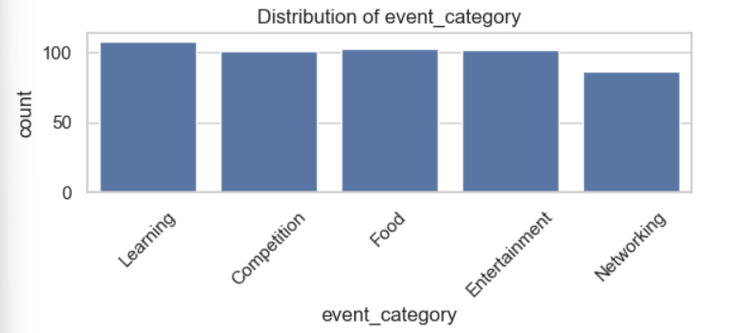

- Figure 2: Average attendance by event type
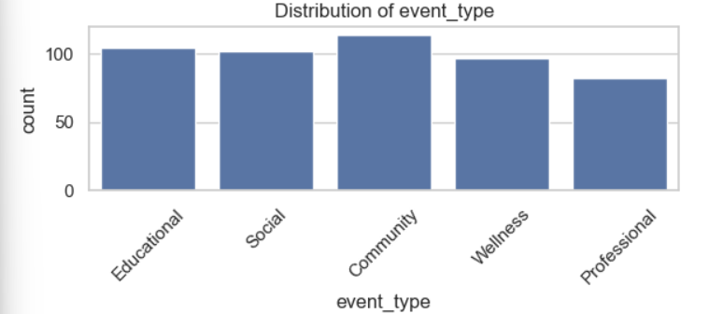

- Figure 3: Promotion method impact
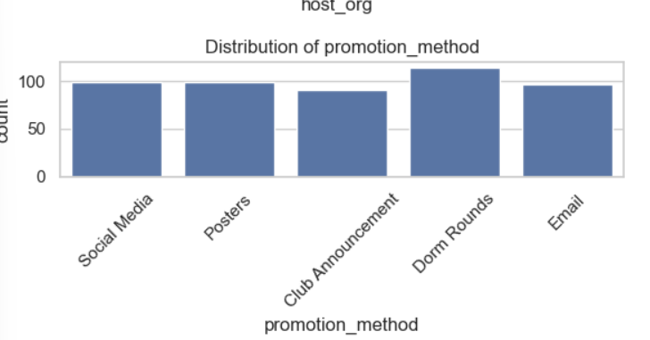
- Figure 4: Distribution of weather
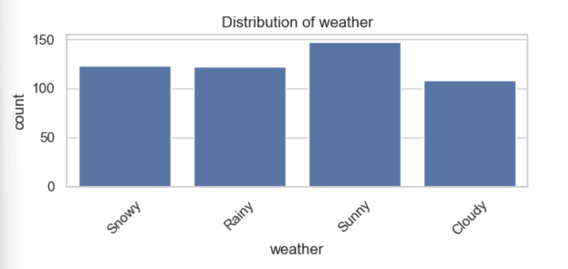
- Figure 5: Distribution of host organisation
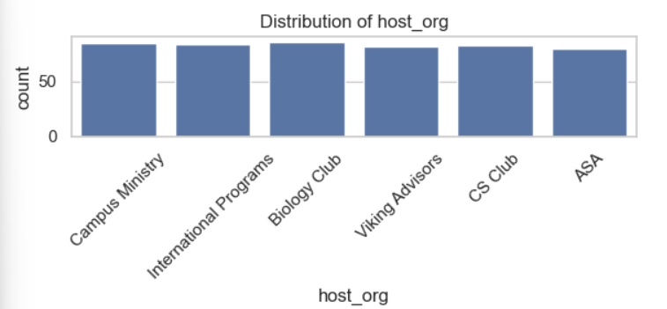

These visuals help show the patterns in the dataset.

5. Methods

5.1 Preprocessing
Before training the models, I prepared the dataset:
- I split the data into 80% for training and 20% for testing.
- I used one-hot encoding for categorical features like event type and promotion method.
- I scaled numeric values such as time of day.
- For the neural network, I converted the dataset into NumPy arrays and created a validation split.

5.2 Models Used

Linear Regression
A simple model that tries to fit a straight-line relationship between event features and attendance.

Decision Tree
A model that splits the data into different branches. Good for capturing rules such as “if free food = yes, attendance is higher.”

Random Forest
A group of many decision trees combined together. Random Forests are usually strong on structured data and help reduce overfitting.

Neural Network
A model with multiple layers that tries to learn more complex patterns.
Architecture used:
- 128 neurons
- 64 neurons
- 32 neurons
- ReLU activation
- Batch Normalization
- Adam optimizer
- Early stopping to reduce overfitting

6. Results
Here are the results for each model:

Table 1: Model Performance

Model | MAE | RMSE | R²
Dummy Baseline | 23.691 | 28.624 | -0.000
Linear Regression | 13.727 | 17.136 | 0.642
Decision Tree | 13.839 | 17.151 | 0.641
Random Forest | 13.172 | 16.724 | 0.659
Neural Network | 20.553 | 25.649 | 0.197

Interpretation
- The Random Forest clearly performed the best. It had the highest R² (0.659) and the lowest RMSE.
- Linear Regression and the Decision Tree were very close in performance, both with R² values around 0.64.
- The Neural Network did poorly with an R² of only 0.197.
This follows common research showing that neural networks often struggle with small structured datasets like mine.

Figures
- Figure 6: Model performance comparison
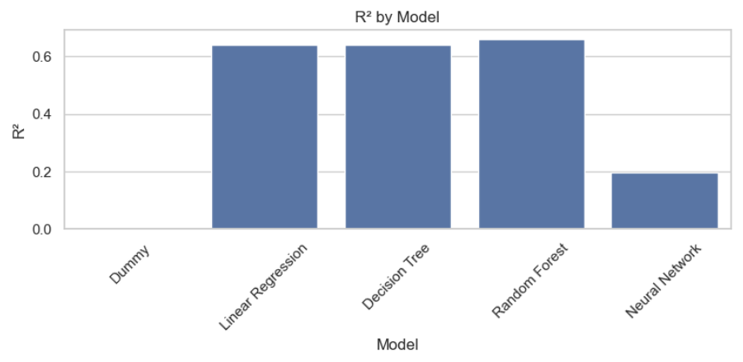

- Figure 7: Neural network loss curve
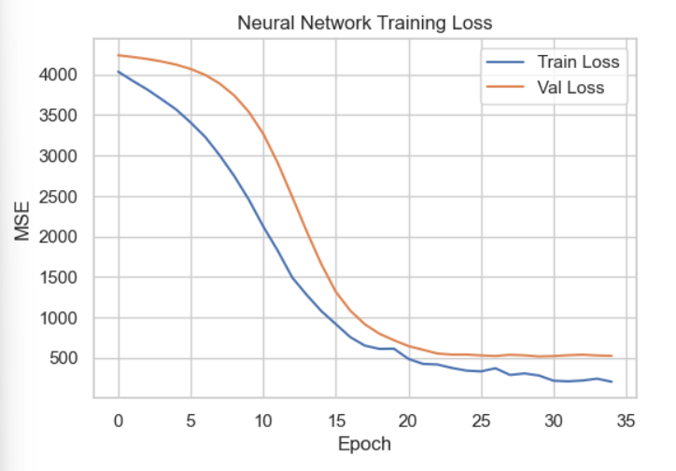

These graphs support my findings.

7. Discussion
The results show that campus event attendance can be predicted fairly well using simple and ensemble machine learning models.

7.1 What Matters Most
The Random Forest feature importance scores showed that certain event details strongly affect turnout:
- Free food
- Event type (social > academic)
- Promotion on social media
- Weekend events
- Giveaways
These match my common experiences as students respond to food, fun, and convenience.

7.2 Why Random Forest Worked Best
Random Forests work well with:
- Mixed numeric and categorical data
- Small to medium datasets
- Nonlinear patterns
- Interactions like “weekend and free food”
This model was the best fit for this type of dataset.

7.3 Why the Neural Network Struggled
The neural network did not perform well because:
- The dataset is too small for deep learning
- Tabular data is harder for neural networks
- It did not capture relationships as efficiently as tree models
- More tuning or a larger dataset would be needed
This supports findings from the 2006 Caruana & Niculescu-Mizil study.

7.4 Real-World Use
These predictions could help:
- Student leaders decide how much food to buy
- Clubs choose the best times and promotion methods
- Administrators plan budgets and space usage

8. Conclusion
This project shows that machine learning can be used to predict event attendance on a college campus with fairly strong accuracy. The Random Forest model was the top performer, reaching an R² of 0.659. Linear Regression and Decision Trees also performed well, while the neural network struggled due to dataset size and structure.
The project also revealed which event features matter most when predicting turnout. Free food, social media promotion, event type, and weekend scheduling all had strong effects.
In the future, this project could be improved by adding RSVP data, real weather forecasts, or multiple years of event records. A larger dataset may allow neural networks to perform better.
Machine learning clearly has potential to help student leaders and departments plan events more efficiently and reduce guesswork.

References
- Zhang, L., Chen, X., & Wang, Y. (2024). Evaluating Machine Learning Algorithms for Predictive Modeling of Large-scale Event Attendance. ResearchGate.
- Tran, M., & Lee, D. (2021). Predicting Event Attendance Using Social and Contextual Features. Proceedings of the ACM Conference on Information and Knowledge Management (CIKM).
- Caruana, R., & Niculescu-Mizil, A. (2006). An Empirical Comparison of Supervised Learning Algorithms. Proceedings of the 23rd International Conference on Machine Learning.

